**ATTENDANCE MANAGEMENT SYSTEM**

A

Micro Project Report

Submitted in partial fulfilment of the

Requirements for the Course of

**SOFTWARE ENGINEERING - LAB**

IN

**BE ¾ (CSE) II-SEMESTER**

By

**B. INDUMANASWINI**

**1602-19-733-072**

**B. VARUN**

**1602-19-733-116**



**Department of Computer Science & Engineering**

**Vasavi College of Engineering (Autonomous)**

**Ibrahim Bagh, Hyderabad-31**

**2022**

**DECLARATION BY THE CANDIDATE**

We, **B. INDUMANASWINI** and **B. VARUN,** bearing hall ticket numbers, **1602-19-733-072 and 1602-19-733-116**, hereby declare that the Case study report entitled **“ATTENDANCE MANAGEMENT SYSTEM”** under the guidance of **Mrs ANUSHA MERUGU,** Assistant Professor, Department of Computer Science & Engineering, VCE, Hyderabad is submitted in partial fulfilment of the requirement for the course of **Software Engineering - Lab** in BE ¾ (CSE) II-Semester.

This is a record of bonafide work carried out by me and the Design embodied in this project report has not been submitted by any other.

**B. INDUMANSWINI,**

**1602-19-733-072,**

**B. VARUN,**

**1602-19-733-116.**

**ACKNOWLEDGEMENT**

We have taken efforts in this project. However, it would not have been possible without the kind support and help of many individuals and organizations. We would like to extend our sincere thanks to all of them. We are highly indebted to Vasavi College of Engineering for their guidance and constant supervision as well as for providing necessary information regarding the project & also for their support in completing the project.

Our thanks and appreciations also go to our colleagues in developing the project and people who have willingly helped us out with their abilities.

**ABSTRACT**

Attendance management system deals with the maintenance of the student’s and employee's attendance details. For a student, it generates the attendance of the student on basis of presence in the class. It is maintained on the daily basis of their attendance. The employee will be provided with the separate username and password to make the student’s status. An accurate report on the student’s attendance is generated. Students will also be given username and password which is different to each of them so that they can check their attendance at any time.

The staff handling the particular subjects responsible to make the attendance for all students. If the student present on that particular period, then the attendance will be calculated. The student’s attendance reports will be sent as SMS to parents on weekly basis. This system will also help in evaluating the eligibility criteria of a student such as eligibility to write an exam. This also maintains the employees(staff) attendance and his leave details. Holidays details will also be maintained.

**TABLE OF CONTENTS**

1. Introduction------------------------------------------------------------------------07

2. Problem Statement----------------------------------------------------------------07

3. SRS----------------------------------------------------------------------------------08

4. System Design--------------------------------------------------------------------14

1. Data Flow Diagram------------------------------14
2. Functional decomposition----------------------17
3. Use-Case Diagram-------------------------------18
4. Sequence Diagram-------------------------------19
5. Collaboration Diagram--------------------------22
6. Activity Diagram---------------------------------24
7. State chart Diagram------------------------------25
8. Class Diagram------------------------------------26
9. Component Diagram-----------------------------27
10. Deployment Diagram----------------------------28

5. Test Cases-------------------------------------------------------------------------29

6. Cost and Resource Estimation and Verification-----------------------------31

7. Conclusion and future scope----------------------------------------------------35

8. References--------------------------------------------------------------------------36

**LIST OF FIGURES**

|  |  |  |
| --- | --- | --- |
| S. No | Figures | Page No |
| 1 | Level 0 DFD | 14 |
| 2 | Level 1 DFD | 15 |
| 3 | Level 2 DFD | 16 |
| 4 | Functional decomposition | 17 |
| 5 | Use-case diagram | 18 |
| 6 | Sequence diagram | 19,20,21 |
| 7 | Collaboration diagram | 22,23 |
| 8 | Activity Diagram | 24 |
| 9 | State chart Diagram | 25 |
| 10 | Class diagram(general) | 26 |
| 11 | Component diagram | 27 |
| 12 | Deployment diagram | 28 |

**INTRODUCTION**

Attendance Management system is the process which is to be maintained in every educational institution. This is the process where the attendance of students and employees(staff) is maintained. The Staff is responsible for posting the attendance of the students after their respective period. Attendance of staff is posted by clerk. Every person has their own login id and password so that they can login to the system and post the respective attendance. An accurate report on the student’s attendance is generated. Students will also be given username and password which is different to each of them so that they can check their attendance at any time. This process also helps to monitor student’s attendance and parallelly helps evaluate the student’s performance. Here, leave details of students and employees is also maintained. Details regarding public holidays is maintained too.

**PROBLEM STATEMENT**

This project is aimed at developing an attendance management system website for educational institutions. The Staff is responsible for posting the attendance of the students after their respective period. Attendance of staff is posted by clerk. Every person has their own login id and password so that they can login to the system and post the respective attendance. An accurate report on the student’s attendance is generated. Students will also be given username and password which is different to each of them so that they can check their attendance at any time. This process also helps to monitor student’s attendance and parallelly helps evaluate the student’s performance. Here, leave details of students and employees is also maintained. Details regarding public holidays is maintained too.

SOFTWARE REQUIREMENTS SPECIFICATION

Table of Contents

1. **Introduction**

1.1 Purpose

1.2 Scope

1.3 Definitions, Acronyms, and Abbreviations

1.4 References

* 1. Overview

**2. General Description**

2.1 Product Perspective

2.2 Product Functions

2.3 User Characteristics

2.4 General Characteristics

**3. Specific Requirements**

3.1 Functional Requirements

3.2 Performance Requirements

3.3 Non-Functional Requirements

3.4 Design Constraints

**Software Requirements Specification**

**(Attendance management system)**

1. **Problem Statement:** To collect software requirements and create software requirement specification.

**SOFTWARE REQUIREMENTS:** Ms Word.

**1. Introduction**

**1.1 Purpose Basic Description of Problem**

The attendance management system is an important part in education institution. The attendance details of each student studying in their institution should be maintained by the institution.

**1.2 Scope**

The purpose of this specification is to document requirements for a system to manage the student’s attendance information. The specification identifies what such a system is required to do. The specification is written in a format conforming to the IEEE Standard 830- 1984. Subject to approval, the specification will complete the Requirements phase and will be followed by detailed design, implementation, and testing.

**1.3 Definitions, Acronyms, and Abbreviations**

**AMS** Attendance Management System

**GUI** Graphical User Interface

**SID** Student Identification Number

**EID** Employee Identification Number

**1.4 References**

Attendance Management System Fedena, is a complete Attendance management software and system with features like: attendance percentage, number of classes present, number of classes absent, periods for which the student is absent. For employee, the features are leave details, days in which he is present.

**1.5 Overview**

This specification includes a brief product perspective and a summary of the functions the software will provide. User characteristics are discussed and any general constraints or assumptions and dependencies are listed.

Requirement statements are categorized as functional requirements, performance requirements, non-functional requirements, or design constraints. Functional requirements are further categorized in terms of employee management subsystem, employee’s attendance management system data updating of students. Non-functional requirements are further categorized in terms of security, maintainability, and scalability.

2. General Description

**2.1 Product Perspective**

The AMS is designed to help the student to handle each and every student’s attendance information studying in an institution and also maintains the attendance details of an employee teaching in an institution. The current design goal is to build an internal system to achieve the functionality outlined in this specification.

**2.2 Product Functions**

The AMS will allow the user to manage information about Student’s and employee’s attendance. Every student will be given their SID and password so that they can check their attendance. Data updating here means the timetable, attendance percentage, class in which student is studying. The AMS will also support the automatic backup and protection of data.

**2.3 User Characteristics**

There are three different types of users for the AMS system:

Type 1. Admin, who handles the entire AMS system. Admin is the one who designs this AMS

and also makes changes in the AMS. He is the one who maintains this whole AMS. He also makes changes in the GUI.

Type 2. Employee, who handle data entry for the AMS system. They have knowledge regarding posting the attendance of students in an institution. Employees are familiar with basic computer operations.

Type 3. Clerk, who also handles data entry for the AMS system. He posts employee’s attendance.

Type 4. Students, who use this whole system so that they can check their attendance details but cannot modify any information.

Based on the above categorizations, in order to meet user's needs the following precautions should be taken:

* the interface should be designed with the computer novice in mind
* attendance calculation function should be correct
* error messages should be provided.
* the interface should be easy to understand.

**2.4 General Constraints**

The following constraints will limit the developer's options for designing the system:

1. the budget for this project is twenty thousand.
2. implementation is required within 10 weeks.

3. Specific Requirements

* + **Functional Requirements**

**R1. Employee Management Subsystem**

The employee management subsystem requirements are concerned with the management of staff information. They specify how staff information can be managed.

**R 1.1** The AMS shall allow the user type 2 to post student’s attendance.

**R1.1.1 Student’s** attendance is posted by taking SID

**R1.1.2**. EID and their password is required so that they can login and post student’s attendance.

**R1.1.3.** Confirm again before submission as once posted attendance cannot be modified

**R2. Employee’s attendance Management System**

**R2.1** The AMS shall Allow the user type 3 to post employee’s attendance

**R2.1.1 Employee’s** attendance is posted by taking EID

**R2.1.2.** Confirm again before submission as once posted attendance cannot be modified

**R3 Data Updation for students**

**R3.1 Student** attendance information management

**R3.1.1** Update Student attendance sheet

**R3.2** Class Information updation

**R3.2.1 Update** the time table of a class.

**R3.2.2** Update the examination schedule.

**R3.2.3** Display notification if any.

**3.2 Performance Requirements**

**R4** The AMS shall respond to user's retrieving information quickly. The waiting time for any retrieve operation must be under 2 seconds.

**3.3 Non-functional requirements**

**R5. Security**.

The security requirements are concerned with security and privacy issues. All student information is required by law to be kept private

**R 5.1** The AMS shall support different user access privileges.

**R 5.2** The AMS shall protect student information.

**R6. Maintainability**

The maintainability requirements are concerned with the maintenance issues of the system.

**R 6.1** The maintenance time of AMS shall be done regularly.

**R 6.2** System down time for maintenance should be less than 6 hours per quarter of a year.

**R7. Scalability**

The scalability requirements are concerned with the scalable issues of the system.

**R 7.1** The AMS shall be able to scale up to support more workstations. System performance shall not degrade if up to twenty percent (20%) more workstations are added.

**3.4 Design Constraints**

**R 8.** The AMS shall have a graphical user interface.

**R 9.** The AMS must run in the 3rd year computing labs.

**R 10.** The AMS must be written in Java.

**SYSTEM DESIGN**

**I)DATA FLOW DIAGRAMS**

**Level 0:**

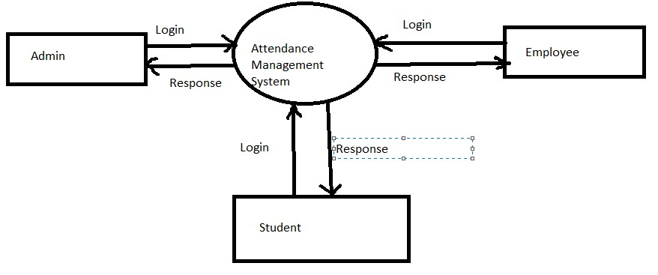

**Level 1:**

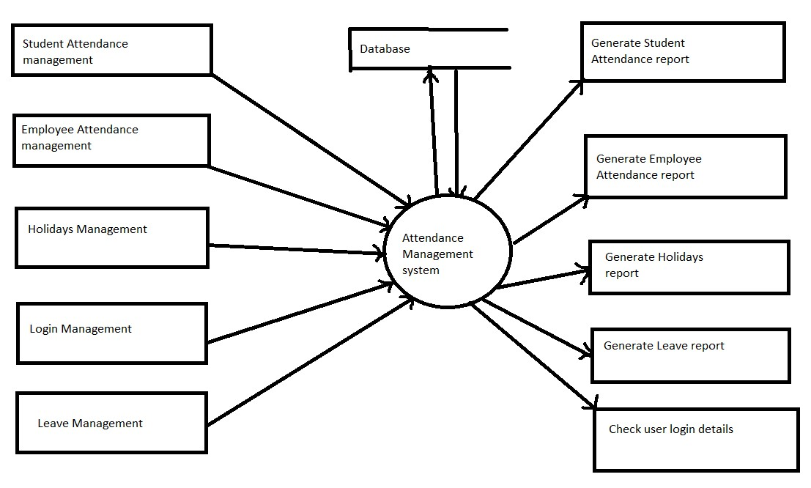

**Level 2:**

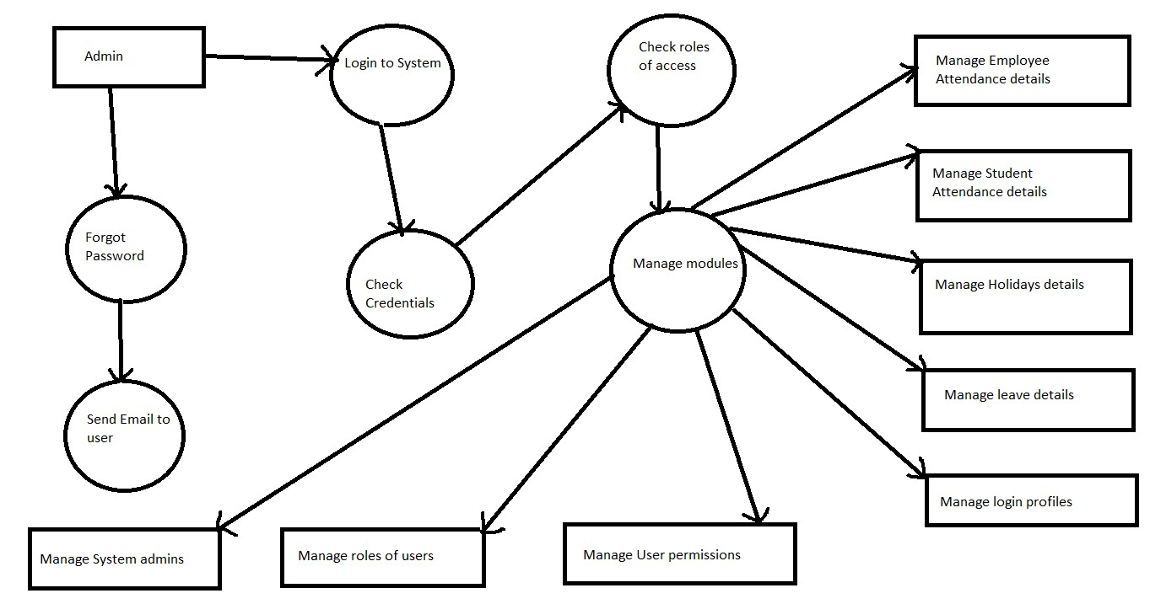

**II) FUNCTIONAL DECOMPOSITION**

**Functional Decomposition**

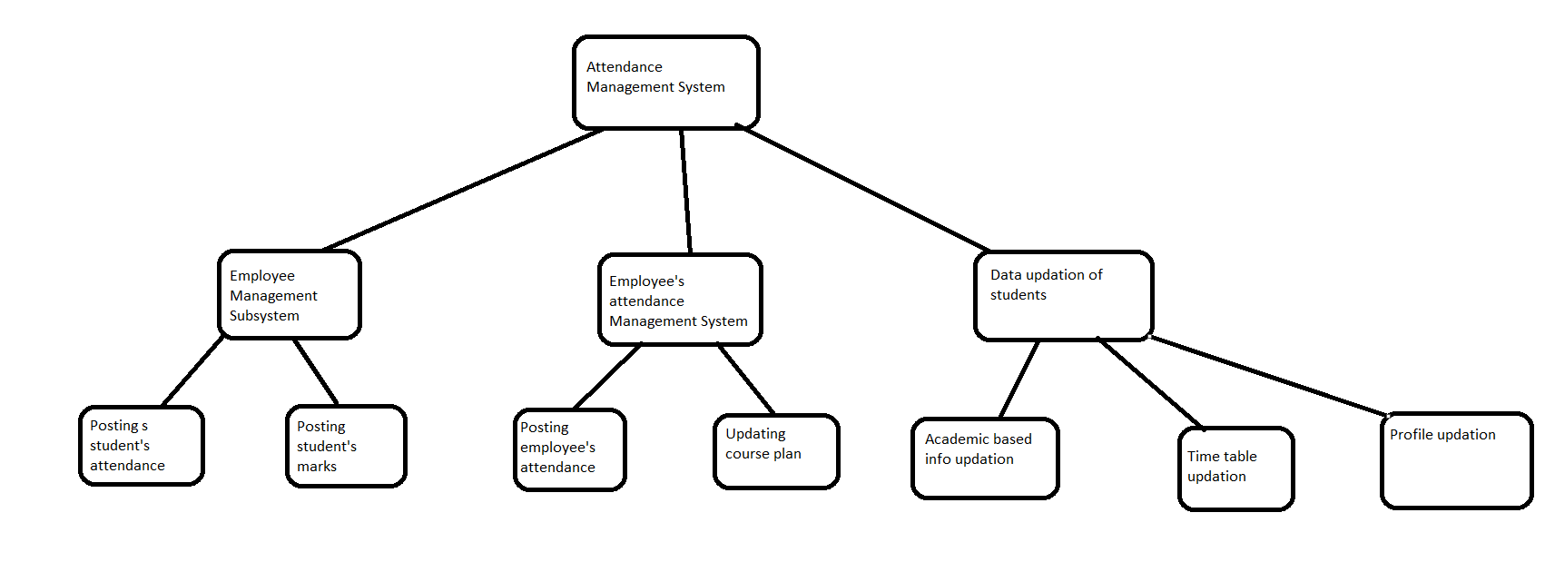

**III) USECASE DIAGRAM**

.

**DIAGRAM:**

**AIM:** Use Case Diagram for Attendance Management System.

**REQUIREMENTS:**

**HARDWARE** **:** PIII Processor, 512 MB RAM, 80GB

**SOFTWARE** **:** In Rational rose software using Use case

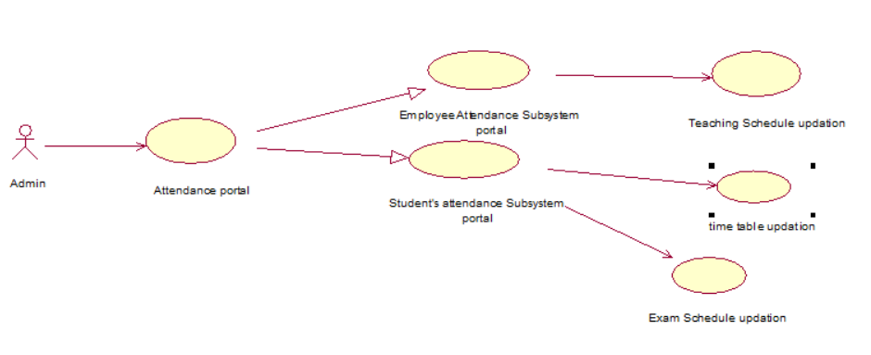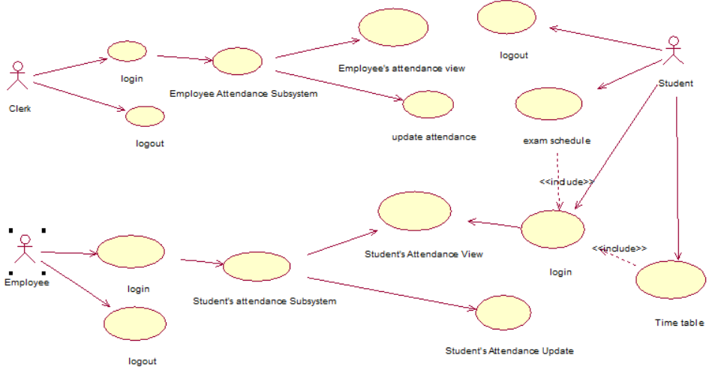

**IV) SEQUENCE DIAGRAM**

**DIAGRAM:**

**AIM:** To draw sequence diagram for Attendance Management System.

**REQUIREMENTS:**

**HARDWARE** **:** PIII Processor, 512 MB RAM, 80GB

**SOFTWARE** **:** In Rational rose software using sequence Diagram tool.

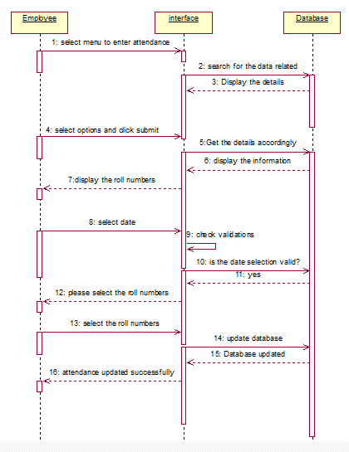

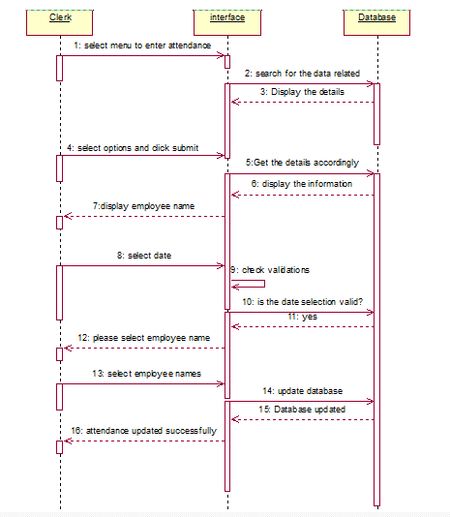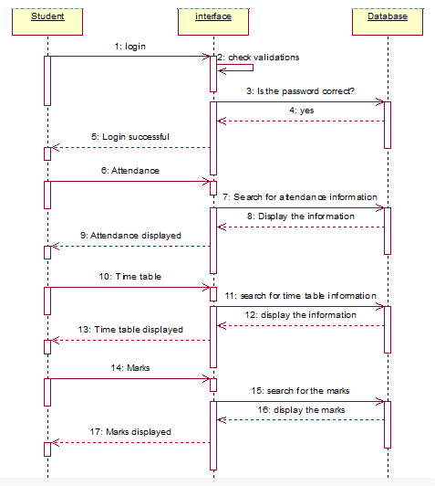

**V) COLLABORATION DIAGRAM**

**DIAGRAM:**

**AIM:** To draw Collaboration diagram for Attendance Management System.

**REQUIREMENTS:**

**HARDWARE** **:** PIII Processor, 512 MB RAM, 80GB

**SOFTWARE** **:** In Rational rose software using Collaboration

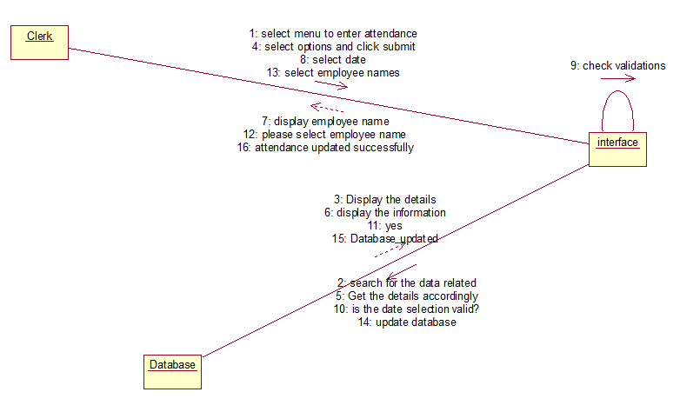

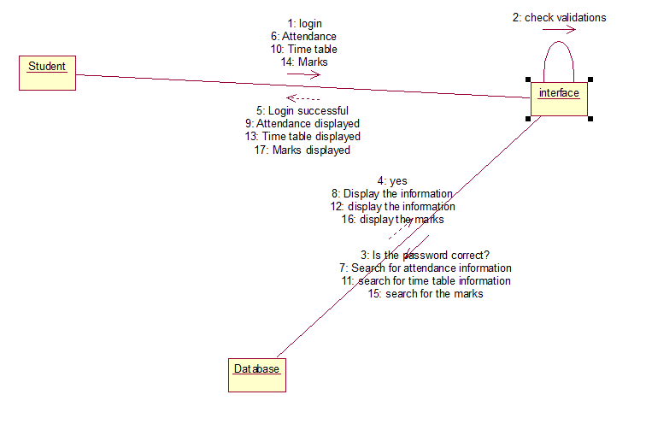



**VI) ACTIVITY DIAGRAM**

**DIAGRAM:**

**AIM:** To draw Activity diagram for Attendance Management System.

**REQUIREMENTS:**

**HARDWARE** **:** PIII Processor, 512 MB RAM, 80GB

**SOFTWARE** **:** In Rational rose software using Activity diagram tools.

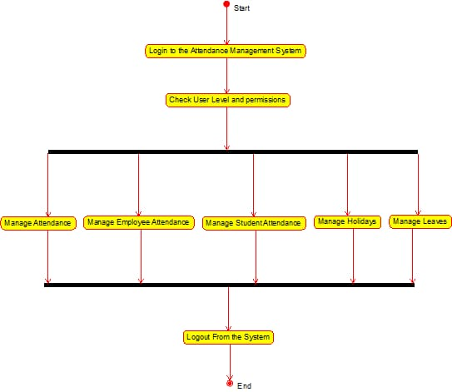

**VII) STATE CHART DIAGRAM**

**DIAGRAM:**

**AIM:** To draw State Chart diagram for Attendance Management System.

**REQUIREMENTS:**

**HARDWARE** **:** PIII Processor, 512 MB RAM, 80GB

**SOFTWARE** **:** In Rational rose software using State diagram tools.

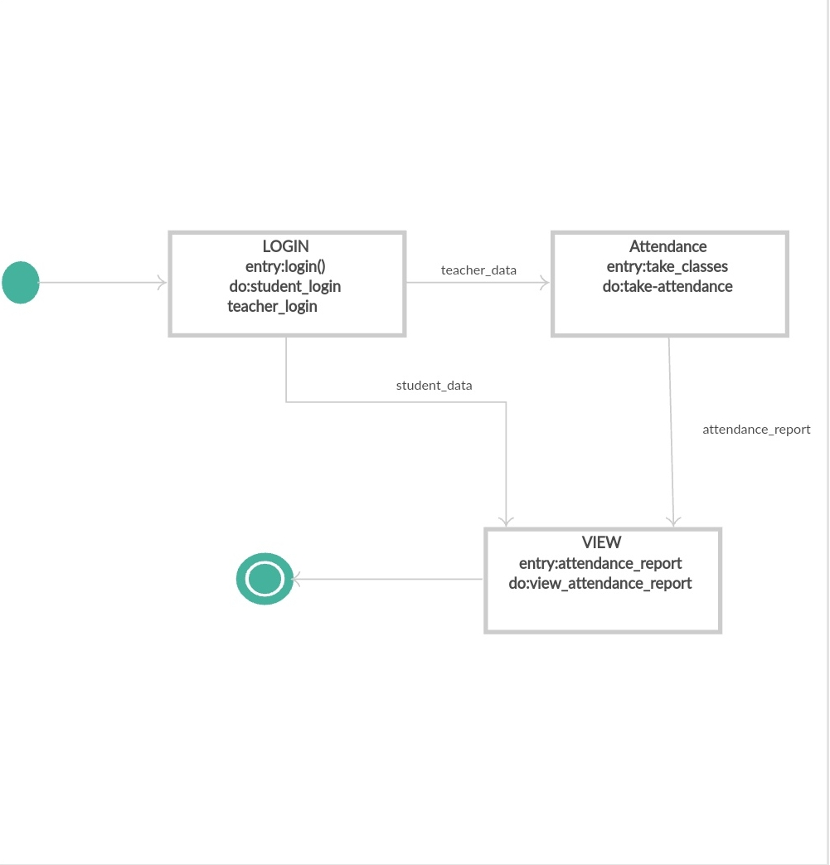

**VIII) CLASS DIAGRAM**

**DIAGRAM:**

**AIM:** To draw simple Class diagram for Attendance Management System.

**REQUIREMENTS:**

**HARDWARE** **:** PIII Processor, 512 MB RAM, 80GB

**SOFTWARE** **:** In Rational rose software using Class diagram tools.

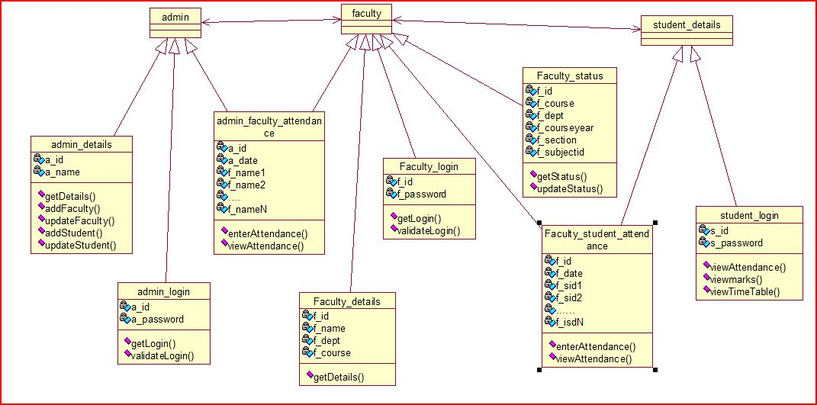

**IX) COMPONENT DIAGRAM**

**DIAGRAM:**

**AIM:** To draw Component diagram for Attendance Management System.

**REQUIREMENTS:**

**HARDWARE** **:** PIII Processor, 512 MB RAM, 80GB

**SOFTWARE** **:** In Rational rose software using component diagram

tools.

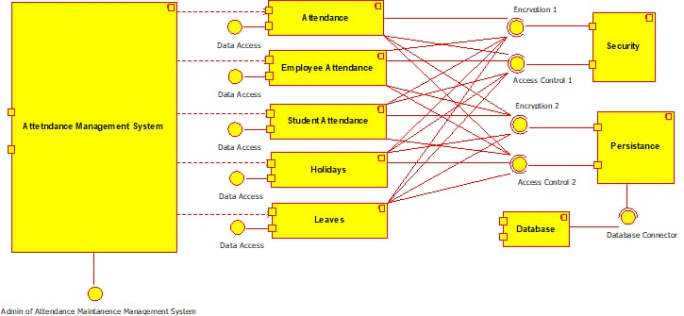

**X) DEPLOYMENT DIAGRAM**

**DIAGRAM:**

**AIM:** To draw Deployment diagram for Attendance Management System.

**REQUIREMENTS:**

**HARDWARE** **:** PIII Processor, 512 MB RAM, 80GB

**SOFTWARE:** In Rational rose software using Deployment diagram tools.

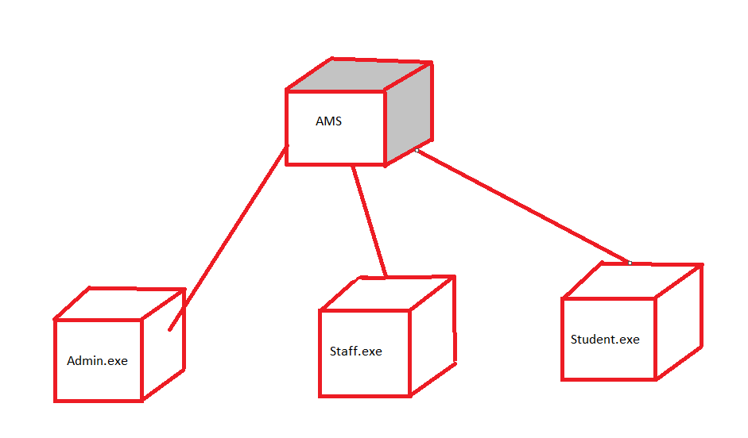

**TEST CASES**

A good [Test](https://www.guru99.com/test-case.html) [Case](https://www.guru99.com/test-case.html) template maintains test artifact consistency for the test team and makes it easy for all stakeholders to understand the test cases. Writing test case in a standard format lessen the test effort and the error rate. Test cases format are more desirable in case if you are reviewing test case from experts.

|  |  |
| --- | --- |
| **Pre-condition**: | Any requirement that needs to be done before execution of this test case. |
|  | To execute this test case, list all pre-conditions |
| **Dependencies**: | Determine any dependencies on test requirements or other test cases |
| **Test Steps**: | Mention all the test steps in detail and write in the order in which it requires to be executed. While writing test steps ensure that you provide as much detail as you can |
| **Test Data**: | Use of test data as an input for the test case. Deliver different data sets with precise values to be used as an input |
| **Expected**  **Results**: | Mention the expected result including error or message that should appear on screen |
| **Post-**  **Condition**: | What would be the state of the system after running the test case? |
| **Actual Result**: | After test execution, actual test result should be filled |
| **Status**  **(Fail/Pass):** | Mark this field as failed, if actual result is not as per the estimated result |
| **Notes**: | If there are some special conditions which is left in above field |

**Login**

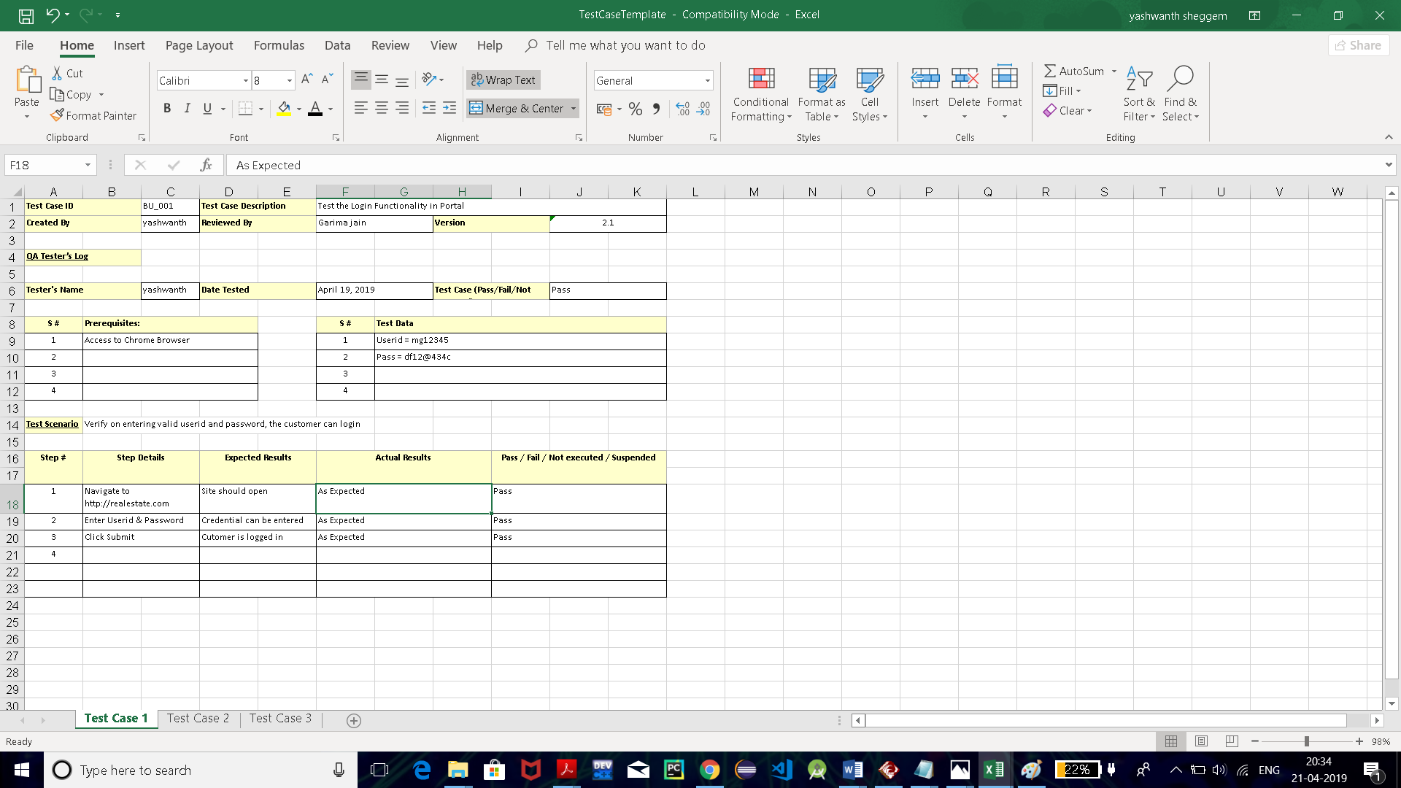

**Select class(period):**

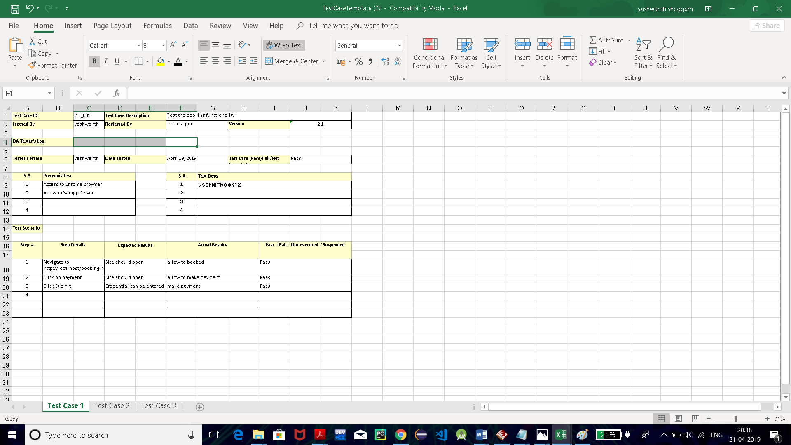

**COST AND RESOURCE ESTIMATES**

**AIM:** To estimate cost and resource for Attendance Management System.

**THEORY:**

This estimation has to be done to develop a product in economically achieving high quality, performance, maintainability.

Total

Cost:

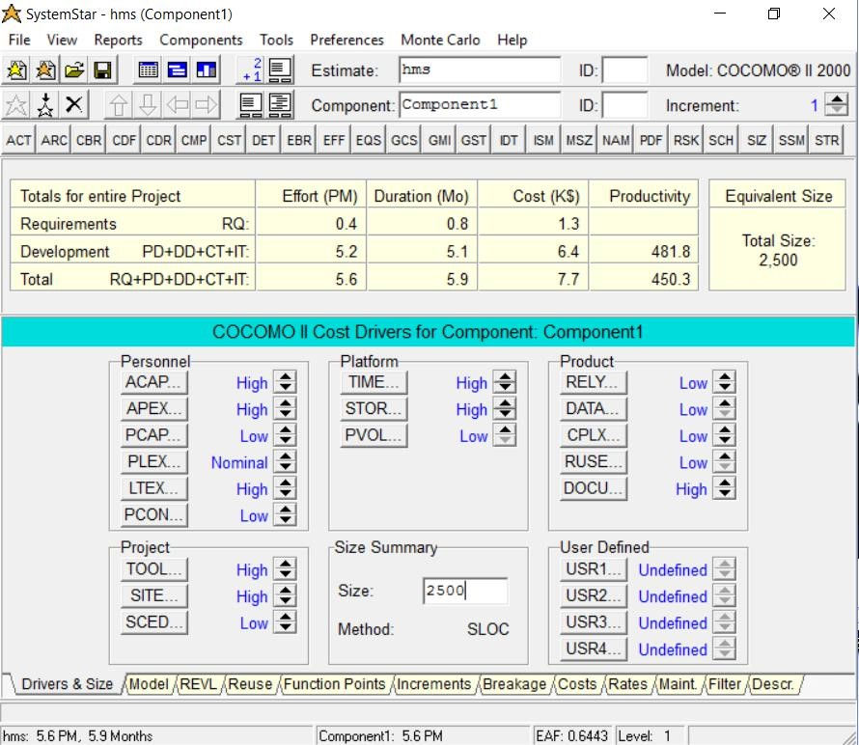

**Activity Report:**

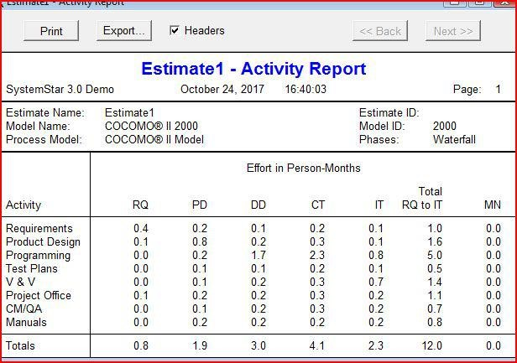

**Archive Report**:

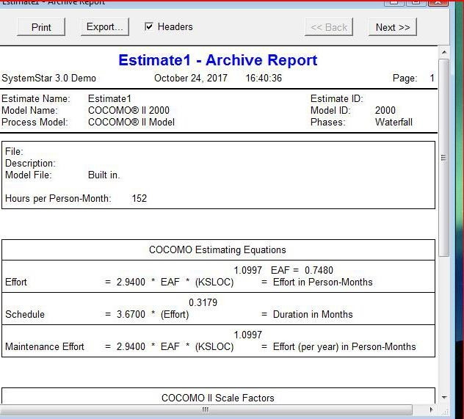

**Effort:**

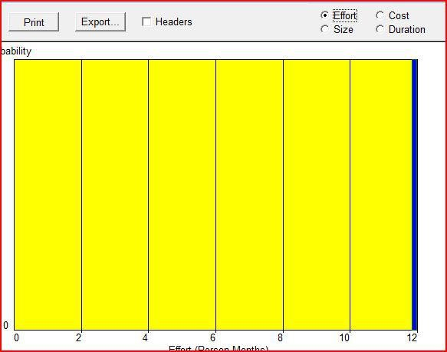

**Size:**

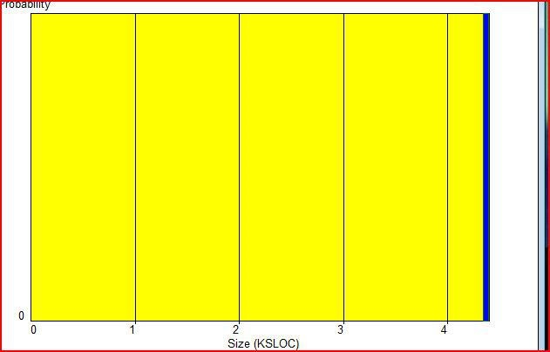

**Scale Drivers:**

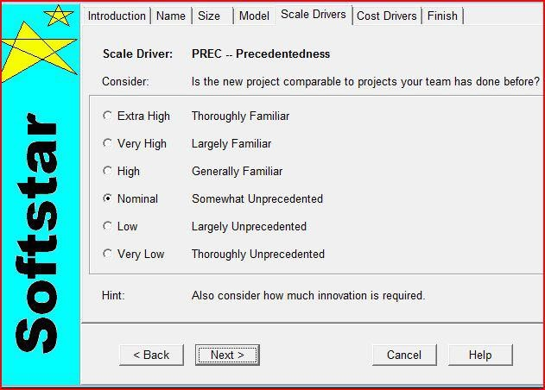

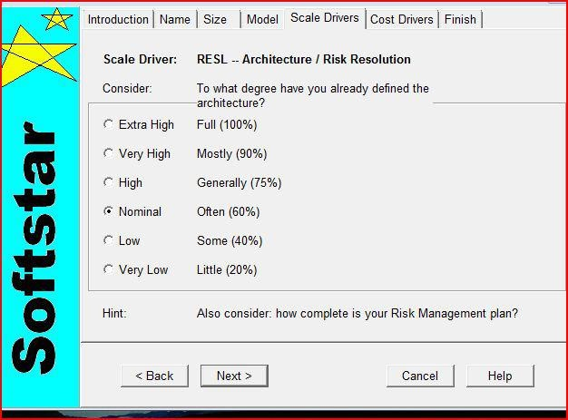

**CONCLUSION AND FUTURE SCOPE**

**CONCLUSION:**

The intention of developing Attendance Management System is to computerized the tradition way of taking attendance. Another purpose for developing this software is to generate the desired reports automatically at the end of the session or in the between of the session as they require.

This project is basically a desktop application which means self-contained software runs on the system on which it has been installed under the user control and it will work for a particular institute or college only.

**FUTURE SCOPE:**

There are also few features which can be integrated with this system to make it more flexible. Below list shows the future points to be consider.

* Online attendance management system can be developed.
* Students cannot bunk the classes because the attendance report of each period will be sent to their parents.

**REFERENCES**

1. <https://www.phptpoint.com/projects/attendance-management-system/>

2. <https://www.slideshare.net/SikandarPandit/attendance-management-system-121793239>